Octal Integer
An integer value with base 8 is called octal integer
This integer value is constructed or created using digits range
from 0-7.
This integer value is prefix with 0o or 0O

>>> n1=0o45
>>> n1
37
>>> n2=0O67
>>> n2
55
>>> n3=0o78
SyntaxError: invalid digit '8' in octal literal
>>> n4=0o89
SyntaxError: invalid digit '8' in octal literal
>>> n5=0o921
SyntaxError: invalid digit '9' in octal literal

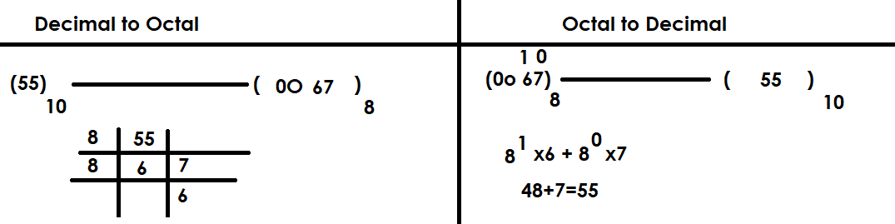

Applications of octal integer
- Operating System
- Networking (IP-Address)
- Assembly Language

Hexadecimal Integer
An integer value with base 16 is called hexadecimal integer
This integer value is created using digits range from 0-9,A-F/a-f
This integer value is prefix with 0x or 0X

Applications
- Color Values
- Memory Address
- Register Address
- UNICODE

If integer value is very large it is represented in hexadecimal format.

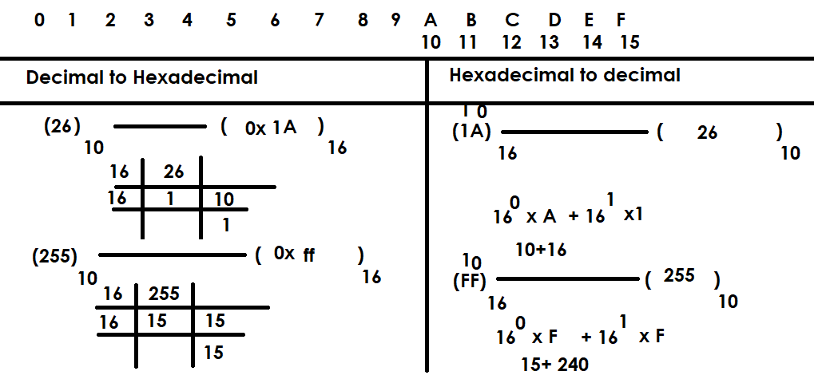

Example:
n1=0xA
n1
10
>>> n2=0XB
>>> n2
11
>>> n3=0xF
>>> n3
15
>>> n4=0xG
SyntaxError: invalid hexadecimal literal
>>> n5=0x1a
>>> n5
26
>>> n6=0xa1b
>>> n6
2587
>>> n7=0xff
>>> n7
255
>>> n1=0x5
>>> n1
5
>>> n2=0xbee
>>> n2
3054
>>> n3=0xbad
>>> n3
2989
>>> n4=0x1hb
SyntaxError: invalid hexadecimal literal

Binary Integer literals
An integer value with base 2 is called binary integer.
An integer value created using 2 digits 0 or 1
This integer value is prefix with 0b or 0B

Applications
- Image processing
- Machine Language
- Embedded applications
- Low Level Programming
- Memory Representation

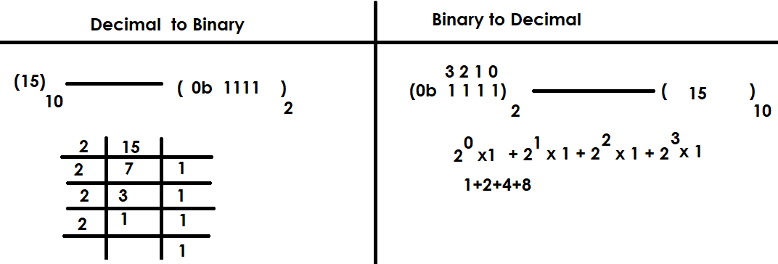
>>> num1=0b101
>>> num1
5
>>> num2=0b1010
>>> num2
10
>>> num3=0b120
SyntaxError: invalid digit '2' in binary literal

One special character is allowed inside integer literals or values called _.
This underscore is used for grouping digits
This number should not prefix or suffix with _

>>> amt=1,00,000
>>> amt
(1, 0, 0)
>>> type(amt)
<class 'tuple'>
>>> amt=1_00_000
>>> amt
100000
>>> x=10_
SyntaxError: invalid decimal literal
>>> y=_10
Traceback (most recent call last):
File "<pyshell#35>", line 1, in <module>
y=_10
NameError: name '_10' is not defined
>>> z=1_0_0_2_3_4
>>> z
100234

float data type and float literals

float data type is used to represent float value or float literal.

What is float value or literal?
A numeric value with decimal part or fractional part is called float value.

These float values in memory represented using float data type or class.

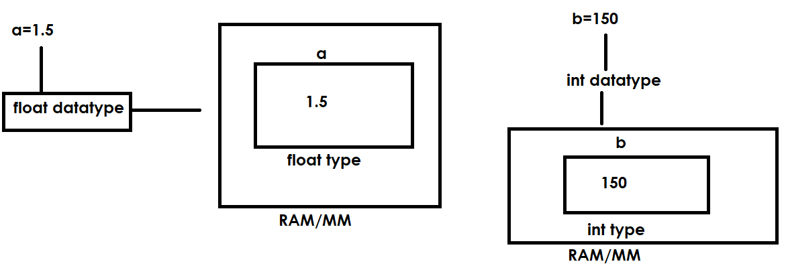

pi=3.147
pi
3.147
type(pi)
<class 'float'>
mean=2.5
mean
2.5
>>> type(mean)
<class 'float'>
>>> median=10.50
>>> median
10.5
>>> type(median)
<class 'float'>
>>> sub1=99.45
>>> sub1
99.45
>>> type(sub1)
<class 'float'>

In python float values or literals are represented in 2 formats or notations
- Fixed notation (OR) Decimal Notation (OR) Standard Notation
- Exponential (Scientific) notation

>>> pi=3.147
>>> pi
3.147
>>> type(pi)
<class 'float'>
>>> mean=2.5
>>> mean
2.5
>>> type(mean)
<class 'float'>
>>> median=10.50
>>> median
10.5
>>> type(median)
<class 'float'>
>>> sub1=99.45
>>> sub1
99.45
>>> type(sub1)
<class 'float'>

